Dhanani School of Science and Engineering, Habib University

Lab 4 – Digital to Analog Conversion
Analog & Digital Communication - EE322
Fall 2026

Student Name & ID:___Syed Sualeh, Burair Haider_________________ Date:____________

Objective
The objective of this lab is to design, compare and contrast the following two techniques of digital to analog signal:
1.Binary weighted resistors
2. R-2R ladder

Introduction
Nowadays digital circuitry is being used everywhere. Connecting the digital circuitry to sensor devices will be easy if the sensor devices are also digital. Electronic components like switches, relays, and encoders are easily interfaced with gate circuits due to the on/off nature of their signals.

In communication system, digital transmission is much faster and convenient, but the digital signals need to be converted back to analog signals at the receiving terminal. In this experiment, we will focus on the digital to analog converter, implementing two different circuit designs.

Binary Weighted Resistors DAC:
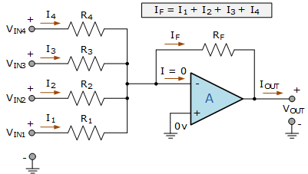
Figure 1: Binary Weighted Resistors DAC. ^{[1]}
The binary weighted resistors DAC has n number of switches, one for each bit applied to the input. The resistors of this circuit are inversely proportional to the numerical significance of its binary digit. Equation shows the computation for the output voltage of the binary weighted resistors.

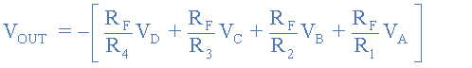… eq 1

R-2R Ladder Network:
R-2R weighted resistor ladder network uses only 2 set of resistors- R and 2R. This is a 4 bit DAC. Let us consider the digital data D₃D₂D₁D₀= 0001 is applied to the DAC, then the Thevenin equivalent circuit reduction is shown on next page.

𝑉_{𝑟𝑒𝑓} is nothing but the input binary value voltage, that is for binary 1, 𝑉_{𝑟𝑒𝑓}=5V and for binary 0,
𝑉_{𝑟𝑒𝑓}=0V.

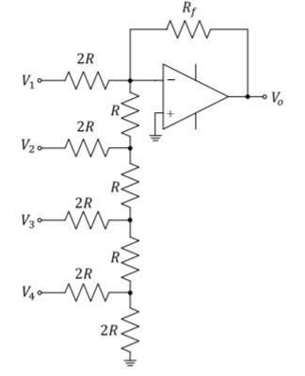
Figure 2: R-2R Ladder Network.

For 0001 only 𝐷₀ = 𝑉_{𝑟𝑒𝑓}, all other input are at 0V and can be treated as ground. So finally 𝑉_{𝑟𝑒𝑓} / 16 volt is appearing as the input to op amp. This value get multiplied by the gain of op amp circuit
– (𝑅_{𝑓}/𝑅_{𝑖}).

If we proceed in this manner (Thevenin equivalent reduction), we will get,

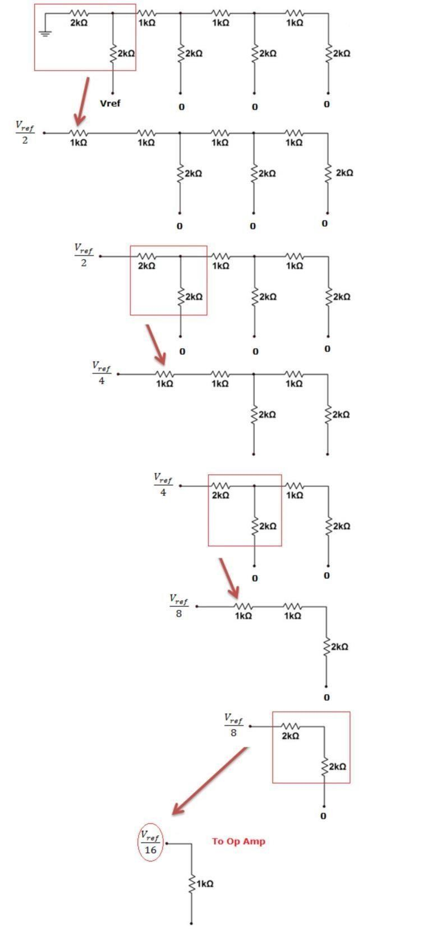

Figure 3: Thevenin equivalent circuit reduction ^{[1]}

Experimental Work

Apparatus Required
The following apparatus are required to perform this experiment.

No. | Apparatus | Specifications | Quantity
1 | DC Power Supply | 0-30 V,1 A | 1
2 | Digital Multi-meter | - | 1
3 | Breadboard | - | 1
Table 1: Apparatus required to perform this experiment.

In-Lab Tasks

Task 1: Implementing a circuit of binary weighted resistors, DAC.

Components Required
The following components are required to perform this experiment.
No. | Components | Specifications / Values | Quantity
1 | Resistors | use different resistors in combination to make binary weighted resistors | ---
2 | Op-Amp | LM741 | 1

Procedure
Implement the following circuit shown
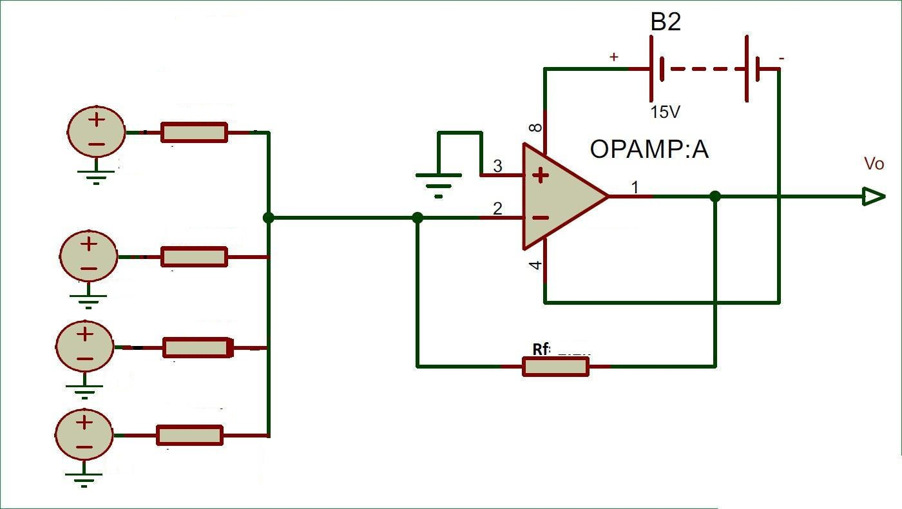

- Using an equation 1. calculate the theoretical values of binary weighted resistors, DAC, output and record them in.
- Obtain all the experimental values of binary weighted resistors,
- Measure voltage level using DMM and record them in Table
- Now calculate percentage error in experimental value by following formula,

S.No | Binary | BWR  theory | BWR  experiment | Error (%)
0 | 0 0 0 0 | 0.000 | 0.002 | N/A
1 | 0 0 0 1 | -0.625 | -0.631 | 0.96
2 | 0 0 1 0 | -1.250 | -1.242 | 0.64
3 | 0 0 1 1 | -1.875 | -1.846 | 1.55
4 | 0 1 0 0 | -2.500 | -2.517 | 0.68
5 | 0 1 0 1 | -3.125 | -3.111 | 0.45
6 | 0 1 1 0 | -3.750 | -3.740 | 0.27
7 | 0 1 1 1 | -4.375 | -4.369 | 0.14
8 | 1 0 0 0 | -5.000 | -4.980 | 0.40
9 | 1 0 0 1 | -5.625 | -5.610 | 0.27
10 | 1 0 1 0 | -6.250 | -6.173 | 1.23
11 | 1 0 1 1 | -6.875 | -6.863 | 0.17
12 | 1 1 0 0 | -7.500 | -7.492 | 0.11
13 | 1 1 0 1 | -8.125 | -8.160 | 0.43
14 | 1 1 1 0 | -8.750 | -8.740 | 0.11
15 | 1 1 1 1 | -9.375 | -9.369 | 0.06

Task 2: Implementing a circuit R-2R ladder network.

Components Required
The following components are required to perform this experiment.
No. | Components | Specifications / Values | Quantity
1 | Resistors | 1k | Use these resistors in combination.
2 | Op-Amp | LM741 | 1
Table 3: Components required to perform In-Lab Task 1.

Procedure
Implement the following circuit shown in Figure

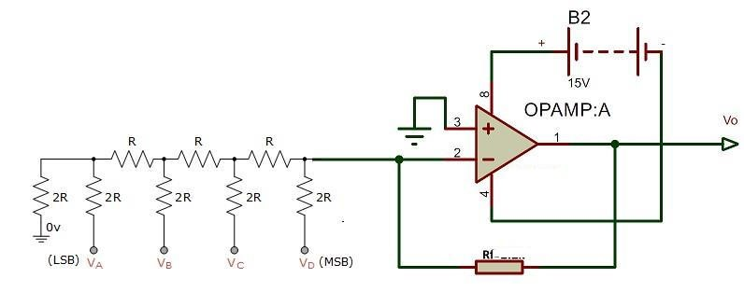
- Using an equation (2), calculate the theoretical values R2R DAC
- Obtain all the experimental values of R-2R ladder network
- Measure voltage level using DMM and record
- Now calculate percentage error in experimental value by following formula,

S.No | Binary | R2R  theory | R2R experiment | Error  (%)
0 | 0 0 0 0 | 0.0000 | 0.0002 | N/A
1 | 0 0 0 1 | -0.3125 | -0.298 | 4.64
2 | 0 0 1 0 | -0.6250 | -0.598 | 4.32
3 | 0 0 1 1 | -0.9375 | -0.911 | 2.83
4 | 0 1 0 0 | -1.2500 | -1.2 | 4.00
5 | 0 1 0 1 | -1.5625 | -1.55 | 0.80
6 | 0 1 1 0 | -1.8750 | -1.788 | 4.64
7 | 0 1 1 1 | -2.1875 | -2.1 | 4.00
8 | 1 0 0 0 | -2.5000 | -2.53 | 1.20
9 | 1 0 0 1 | -2.8125 | -2.764 | 1.72
10 | 1 0 1 0 | -3.1250 | -3.06 | 2.08
11 | 1 0 1 1 | -3.4375 | -3.24 | 5.75
12 | 1 1 0 0 | -3.7500 | -3.69 | 1.60
13 | 1 1 0 1 | -4.0625 | -4.004 | 1.44
14 | 1 1 1 0 | -4.3750 | -4.31 | 1.49
15 | 1 1 1 1 | -4.6875 | -4.61 | 1.65

9 Analog and Digital Communication Lab (EE-322L)
Conclusion:
Compare both digital to analog converters in terms of design and performance.

Both circuits successfully convert a 4-bit digital input into a proportional analog output voltage, confirming the operating principle of Eq. 1 and Eq. 2.

In terms of design, the R-2R ladder is simpler and more practical to build and scale, since it needs only two resistor values (R and 2R) for any number of bits, while the binary weighted resistor DAC needs a distinct, precisely matched resistor for every bit, which is hard to manufacture accurately as resolution increases.

In terms of performance, both circuits tracked their theoretical values closely: the BWR errors were mostly under 1.5% and the R-2R errors were mostly under 5%, with small deviations caused by resistor tolerances, breadboard contact resistance, and op-amp offset.

Overall, although the BWR DAC gave a slightly lower percentage error in this experiment, the R-2R ladder is the more scalable and commercially practical design for higher-resolution DACs.

________________________________________________________________________

What is the voltage step size in task 1 and task 2

Task 1 (Binary Weighted Resistor DAC): step size = V_ref /16 = 5 V /16 = 0.625 V, which matches the 0.625 V spacing between consecutive theoretical values in Table 2.

Task 2 (R-2R Ladder DAC): step size = V_ref /16 = 5 V /16 = 0.3125 V, which matches the 0.3125 V spacing between consecutive theoretical values in Table 4.

Both step sizes equal V_ref divided by 2^n (n = 4 bits); the BWR step is larger because its feedback/input resistor ratio differs from the R-2R network's.

________________________________________________________________________

10 Analog and Digital Communication Lab (EE-322L)
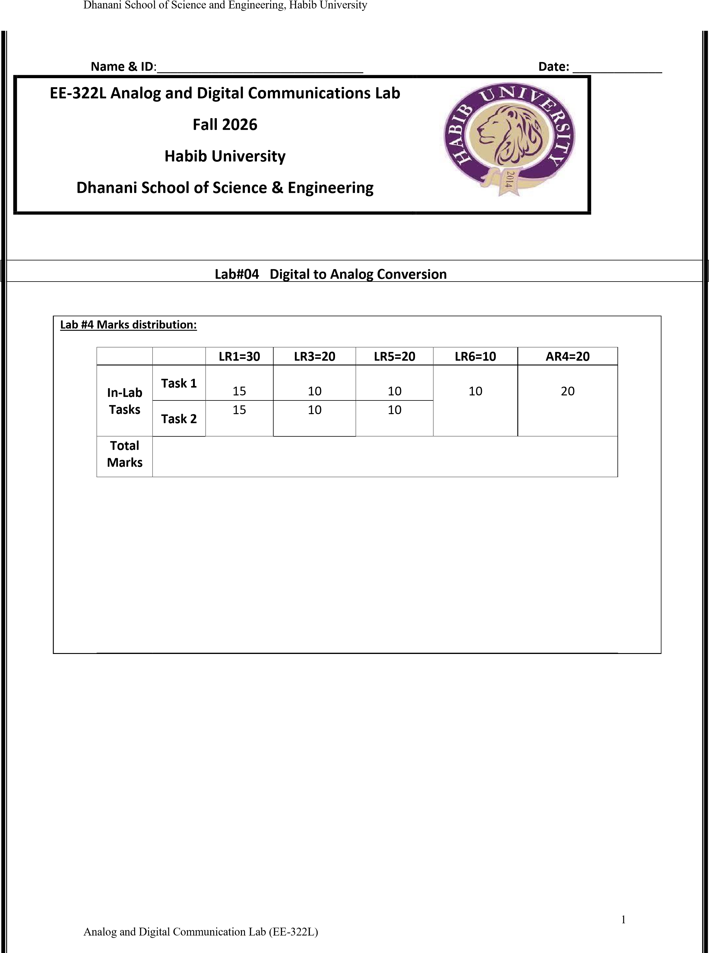

Dhanani School of Science and Engineering, Habib University
Lab Evaluation Assessment Rubric
# | Assessment Elements | (0<Level 1<=4) | (4< Level 2<=6) | (6< Level 3<=8) | (8< Level 4<=10)
LR1 | Neat and Clean Circuit layout | Components are wired and didn’t show neat and clean connections and minimal efforts shown. | Components are wired with untidy connection and didn’t show neat and  clean connections | Few but not all Components are wired with neat and clean  connections | Complete components are wired with neat and clean tight connections. Given task completed in due time.
LR3 | Troubleshooting | Unable to identify the  fault/minimal effort  shown | Able to identify the fault but unable to remove it. | Able to identify the fault but partially removes it. | Able to identify the fault and able to make necessary steps and actions to correct it.
LR4 | Data Collection | Measurements are incomplete, inaccurate and imprecise. Observations are incomplete or not included. Symbols, units and significant figures are not included | Measurements are somewhat inaccurate and very imprecise. Observations are incomplete or recorded in a confusing way. Major errors using symbols, units and significant digits | Measurements are mostly accurate.  Observations are generally complete. Minor errors using symbols, units and significant digits | Measurements are both accurate and precise. Observations are very thorough. Includes appropriate symbols, units and significant digits and completed in due time.
LR5 | Results & Plots | Figures, graphs, tables contain errors or are poorly constructed, have missing titles, captions, units missing or incorrect, etc. | Most figures, graphs, tables OK, some still missing some important or required features | All figures, graphs, tables are correctly drawn, but some have minor problems or could still be improved | All figures, graphs, tables are correctly drawn and contain titles/captions.
LR6 | Clean-up | All equipment/PC is not powered off.  All items left at station and not cleaned. | Many equipment/PC is not powered off.  Many items left at station. | Some equipment/PC is not powered off. Some items left at station. | All equipment/PC is powered off. Station left neat and clean.
LR8 | Contribution | No participation towards the group tasks | Slight participation towards the group tasks | Substantial participation towards the group tasks | Outstanding participation towards the group tasks
LR9 | Report | No summary provided. The number/ amount of tasks completed below the level of satisfaction and/or submitted late. | Couldn’t provide good summary of in-lab tasks. Some major tasks were completed but not explained well. Submission on time. Some major plots and figures provided. | Good summary of In-lab tasks. All major tasks completed except few minor ones. The work is supported by some decent explanations, Submission on time, All necessary plots, and figures. provided | Outstanding Summary of In-Lab tasks, All task completed and explained well, submitted on time, good presentation of plots and figure with proper label, titles and captions.
AR4 | *Report Submission | Late submission after 1 week. | Late submission after 4 days and within a week. | Late submission after the lab timing and after 2 days of the due date. | Timely submission of the report and in lab time.
*Report: Report will not be accepted after 1 week of due date

2
Analog and Digital Communication Lab (EE-322L)

